Introduction
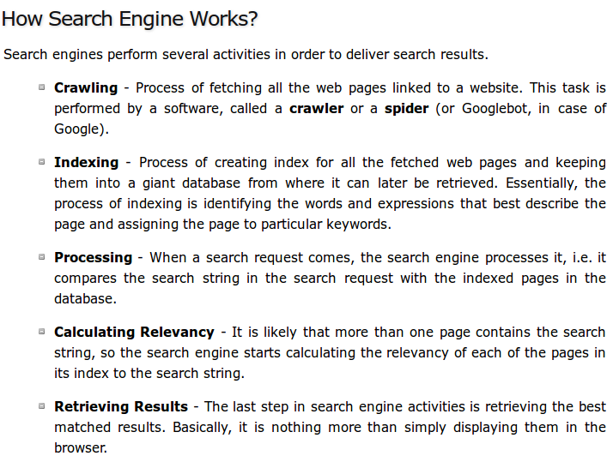

SEO is the process of designing and developing a website to attain a high rank in search engine results.

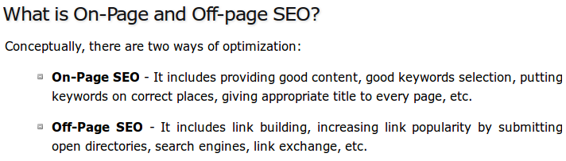
Using keywords in your domain name gives you a strong competitive advantage over your competitors. Having your keywords in your domain name can increase click-through-rates on search engine listings and paid ads as well as make it easier to use your keywords in get keyword rich descriptive inbound links.

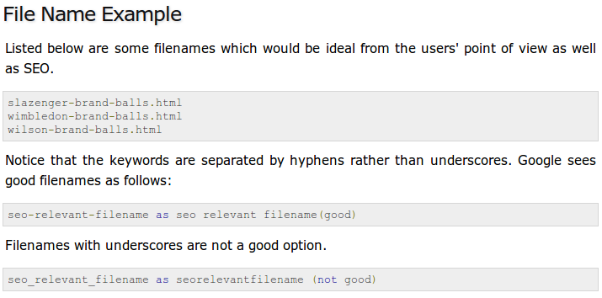
Design & Layout

The actual page content should have a keyword density of about 10% and should weigh in at about 200 words - but there are as many opinions about this as there are SEO experts. Some say, keyword density should be 5% and some say it should be 20%. You can go with 10% which is good enough.

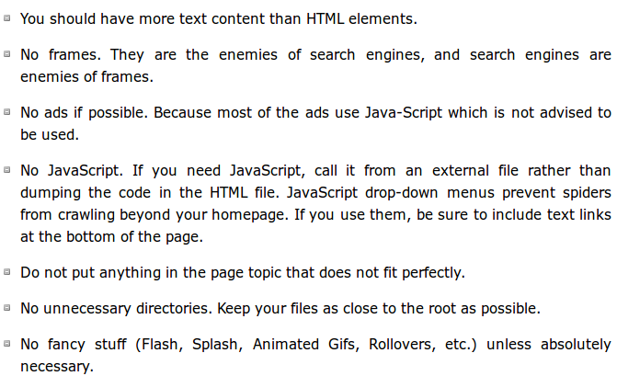

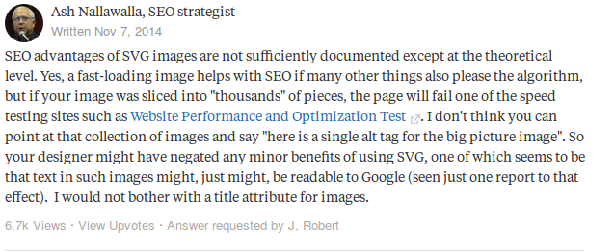
Optimized Keywords

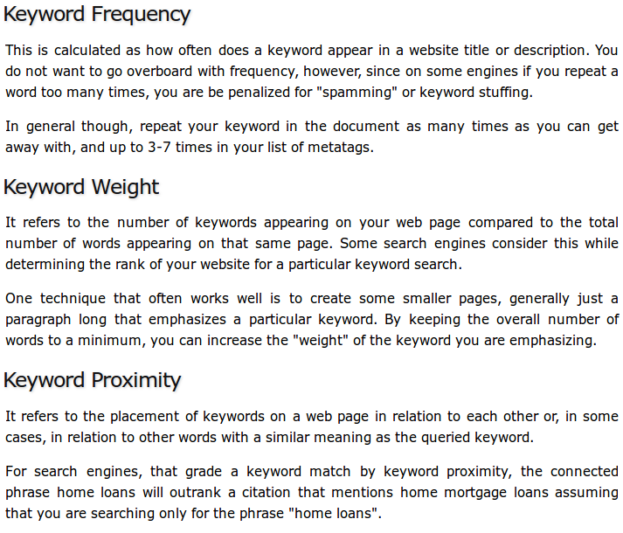

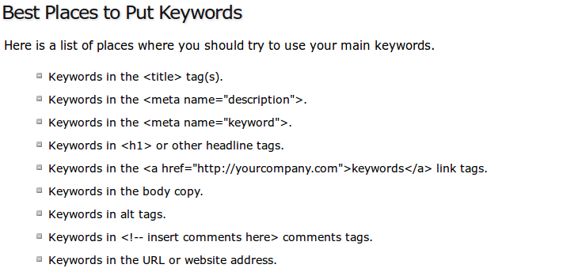
There are many different ways to find keywords for your website. Some good keyword ideas are:
- The potential words, people would use to find your product or service.
- The problems that your prospective customers may try to solve with your product or service.
- Keyword tags on competitor's websites.
- Visible page copy on competitor's websites.
- Related search suggestions on top search engines.
- Using an online tool such as Google Keyword Tool
- By analyzing your website carefully and finding out proper keywords. This task can be done by expert SEO copywriters.
- Pay attention to stemming for your keywords - particularly to what the root word is and what Google considers to be a match for that word, when optimizing pages over time.
- You can do brainstorming to identify correct keywords for your site.

Google uses a feature called word stemming that allows all forms of the word - singular, plural, verb form as well as similar words to be returned for a given search query.
Optimized Metatags

There are two important meta tags:
- Meta description tags
- Meta keyword tags

The general consensus among SEO experts is that metatags are dead. Even so, many of these same experts continue to use metatags in their own sites.

For Google, adding the description meta tag does not result in a boost in the Search Engine Results Pages (SERPs), but the description might be used for the description for your SERP listings in Google.

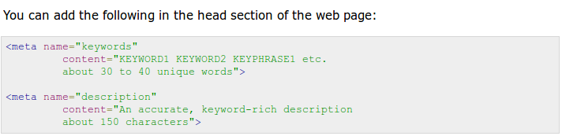
Important tips for good Meta description tags:
- Use keywords in your meta description tag.
- Try not to repeat the words overly often, but try to use multiple syntaxes of your key words.
- There should not be more than 150 characters in a description metatag of a single web page.
- Use a different meta description tag for each page, as each page is different and stands a better chance of being found if you place a good title and description on it.

Title optimization

An HTML TITLE tag is put inside the head tag. The page title (not to be confused with the heading for a page) is what is displayed in the title bar of your browser window, and is also what is displayed when you bookmark a page or add it to your browser Favorites.
This is the one place on a webpage where your keywords MUST be present. Correct use of keywords in the title of every page of your website is extremely important to Google - particularly for the homepage. If you do nothing else to optimize your site, remember to do this!
Here are some considerations while designing the title of a webpage:
- The title shouldn't consist of more than about 9 words or 60 characters.
- Use keywords at the very beginning of the title.
- Do not include your company name in the title unless your company name is very well known.

Improper or nonexistent use of titles in webpages keeps more websites out of top rankings on Google than any other factor except perhaps for a lack of relevant content on a page or a lack of quality links from other websites that point to your site.

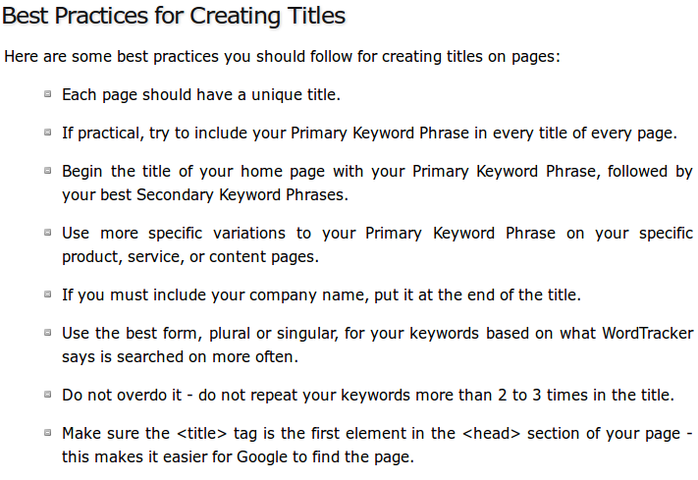
Optimized Anchor

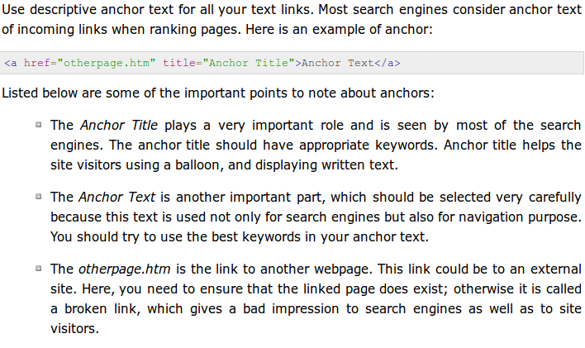

Thousands of articles, books, and forum entries are available on how to make your website search engine friendly, but ultimately, one rule stands above the rest: Unique, high-quality, unduplicated content is the king.

